Guide 2. APT Project Development
Capstone Course

1. Summary of APT Project Progress
Below you will find several fields that you must complete with the requested information.

Summary of APT project progress | During the first seven weeks of the APT project, the team moved from planning to building the system for Ecoterra. The gathering and organization of requirements, the definition of the architecture, the data model, the interface prototype, and the prioritization of features through a Product Backlog were completed.  In the development stage, the interfaces of the system's three modules (operations and inventory management; quotations and invoicing; artificial intelligence) were built and reviewed through page-by-page feedback, which made it possible to detect missing elements, visual adjustments, and inconsistencies with the data model. As a result, the database and the Data Dictionary were updated, adding the necessary tables and attributes (especially for roles and permissions, inventory, movements, quotations, and credit notes).  Also, when development began, the developer Ethan Silvestre identified that a Figma tool made it possible to move from the prototype to the final frontend at the same time. Therefore, in weeks 5 and 6 the team prioritized building the complete frontend of the system instead of developing each feature together with its backend, which led to an adjustment to the methodology planned earlier.  Current status: In week 7, a general review of the frontend was carried out, and it was verified as completed and ready to move on to the next phase. In parallel, Benjamín Mateluna started Sprint 2 (backend and integration of Module 1). The project is therefore at the point of having finished the frontend and being under way with the backend, whose goal is the progressive, module-by-module construction and integration.
Objectives | The initial objectives remain valid, since the adjustment made corresponds to a reorganization of the development strategy and sequence, not to a change in the purpose of the project. Only the KPIs were revised in order to set more realistic values.  General objective: Develop a software system that makes it possible to manage clients, inventory, quotations, and invoicing, incorporating predictive models for Ecoterra.  Specific objectives and progress status:  - SO1. Analyze and document the system's functional and non-functional requirements, defining its architecture and data structure according to Ecoterra's needs.  (KPI: 100% of requirements defined and validated by the client, together with the data model and architecture documented.)  Status: Achieved during the planning and analysis stage. The documented requirements, architecture, data model, and 100% of the associated documentation are defined and validated by the client. During development, updates were made to the data model as a result of the reviews carried out.  - d  - SO2. Develop the operations and inventory management module to manage clients, addresses, products, users, stock, and inventory movements.  (KPI: 90% of the prioritized features of Module 1 implemented and verified through test cases.)  Status: In development. The module's interfaces have been built and are being integrated with the backend through Sprint 2.  SO3. Develop the quotation and invoicing module to manage quotations, purchase orders, invoices, credit notes, and associated PDF documents.  (KPI: 90% of the prioritized features of Module 2 implemented and verified through test cases.)  Status: Pending development. The corresponding interfaces were incorporated into the frontend, and their backend development and integration are planned for Sprints 3 and 4.  SO4. Implement and integrate three predictive models using Scikit-Learn to estimate arrival times, prices, and inventory replenishment needs.  (KPI: 3 of 3 predictive models implemented, evaluated through performance metrics, and available from the system.)  Status: Pending development. Its implementation is planned for Sprint 5.
Metodología | The project maintains Scrum adapted to the academic context with the roles defined previously, organized into the three phases established by the course:  - Phase 1 – Planning: weeks 1 to 4.  - Phase 2 – Development: weeks 5 to 15.  - phase 3 – Presentation and closing: weeks 16 to 18.  Based on the monitoring carried out during Sprint 1, the development sequence was adjusted. Initially, the plan was to advance progressively by feature; however, given the possibility of developing the final frontend ahead of time, the Sprints were reorganized to separate the construction of the frontend from the development and integration of the backend.  The new organization includes:  - Sprint 1 - Weeks 5-6: initial development and completion of the frontend.  - Sprint 2 - Weeks 7-8: backend and integration of Module 1.  - Sprint 3 - Weeks 9-10: backend and integration of quotations and purchase orders.  - Sprint 4 - Weeks 11-12: invoicing, credit notes, PDF, and email.  - Sprint 5 - Weeks 13-14: implementation and integration of the three predictive models.  The methodology includes the following main management deliverables and evidence:  - Product Vision: definition of the product's vision and purpose.  - Prioritized Product Backlog: record and prioritization of the required features.  - Sprint Backlog or board: organization and tracking of the tasks selected for each Sprint.  - Definition of Done: criteria used to determine when a task or feature can be considered done.  - Sprint or cycle sheets: documentation of the objectives, tasks, results, and progress of each Sprint.  - Retrospectives: record of the positive aspects, difficulties, and improvement actions identified at the end of each Sprint.  Applying this methodology allows continuous tracking of progress and adjustments to the plan when development conditions require it.
Evidencias de avance | The selected evidence demonstrates both the technical progress of the project and the correct application of the Scrum methodology.  Management and methodology evidence - The following evidence is presented:  - Product Vision  - Product Backlog  - Trello Board  - Definition of Done  - Sprint 1 Sheet  - Sprint 1 Retrospective  Technical evidence - Evidence of the development carried out will also be included, among them:  - Frontend interfaces of the three modules.  - Reviews and feedback carried out on the interfaces.  - Updated database model.  - Updated Data Dictionary.  - Evidence of the start of Module 1 backend development.  This evidence shows that the project has moved from the analysis and design stage into implementation, maintaining a link between the defined requirements, the technical design, the development, and the Scrum tracking activities.  The quality of the project has been safeguarded through the periodic review of the interfaces, the validation of their correspondence with the requirements and the Data Dictionary, the updating of the data model when inconsistencies were detected, and the tracking of the work using Scrum planning and management tools.

Technical evidence:
- Updated database model:
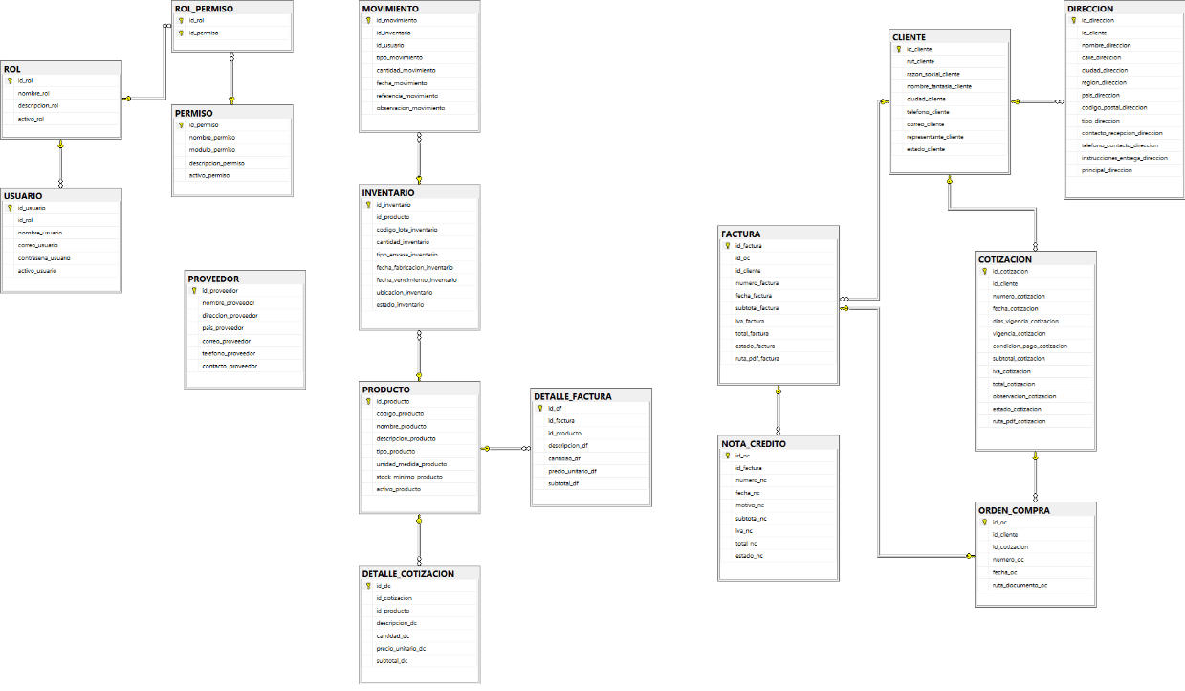
- Link to updated Data Dictionary
- Evidence of the start of the Sprint 2 backend (screenshots of backend-frontend synchronization):
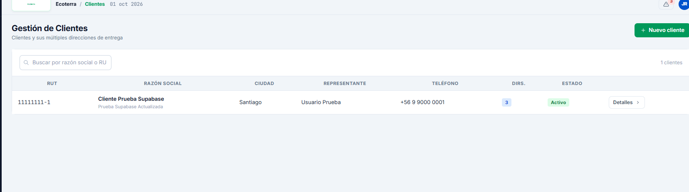
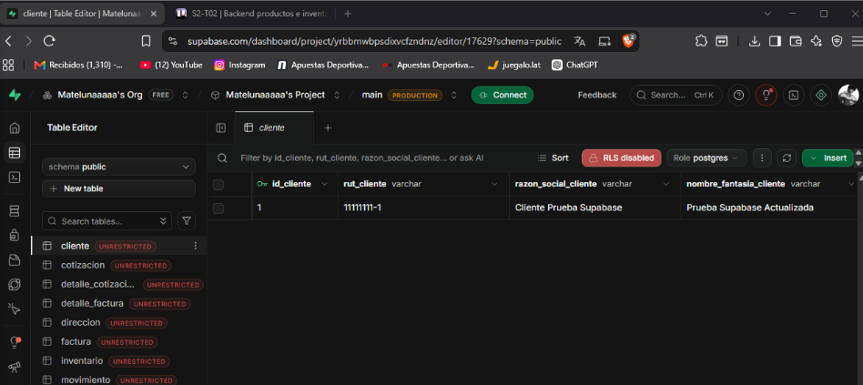

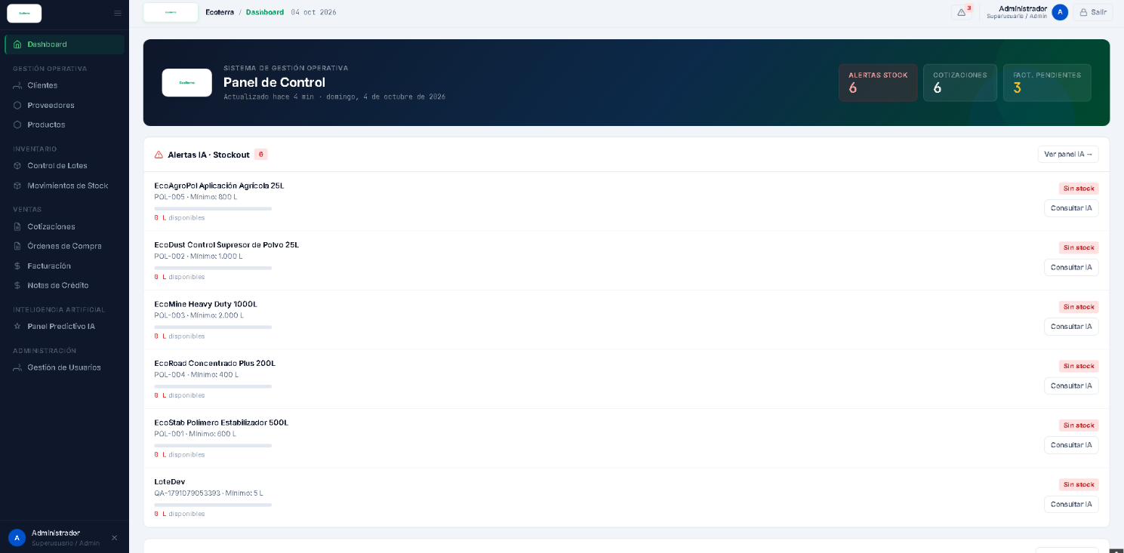
- Frontend screenshots:

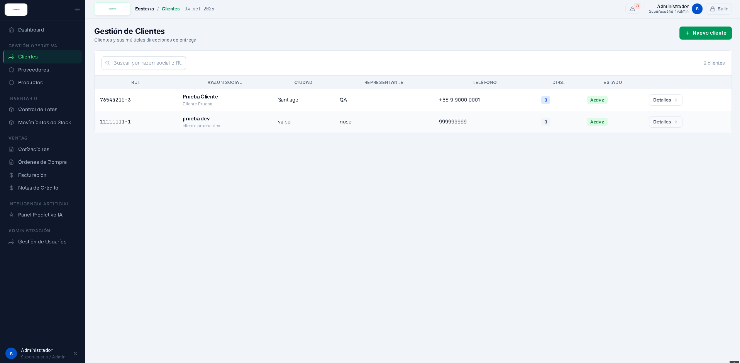

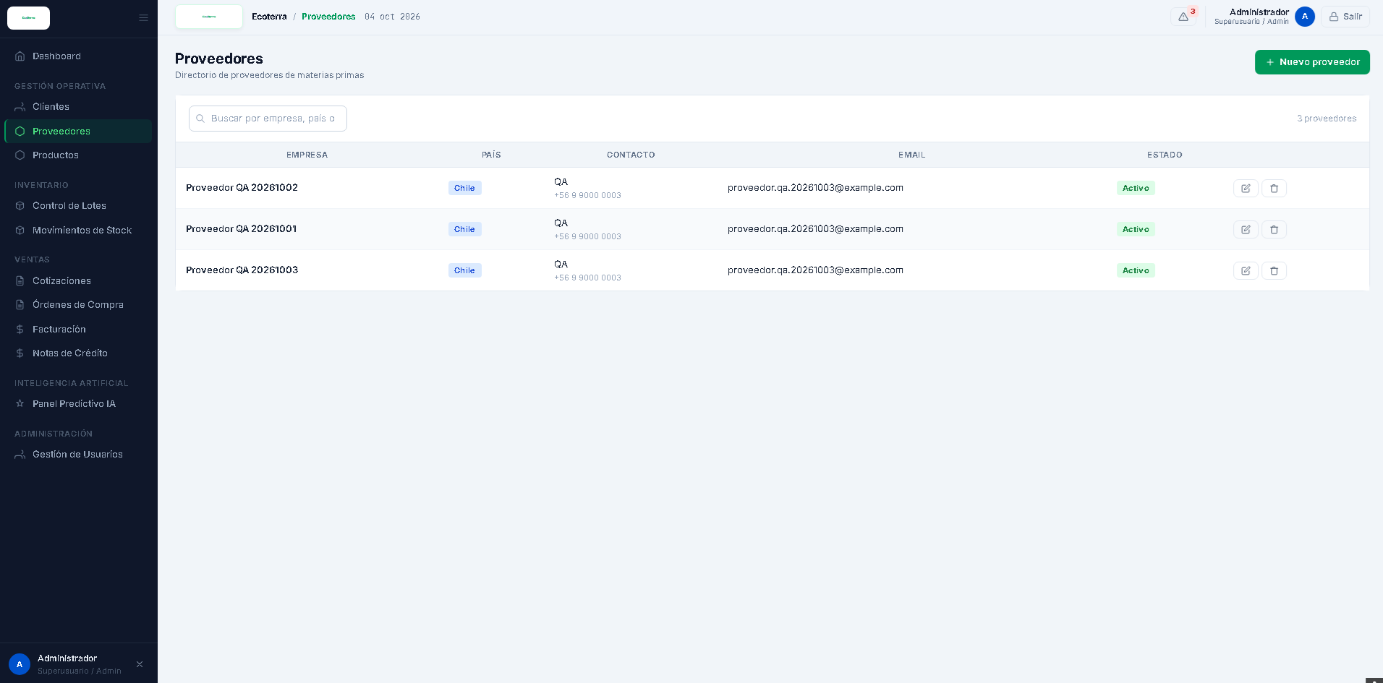

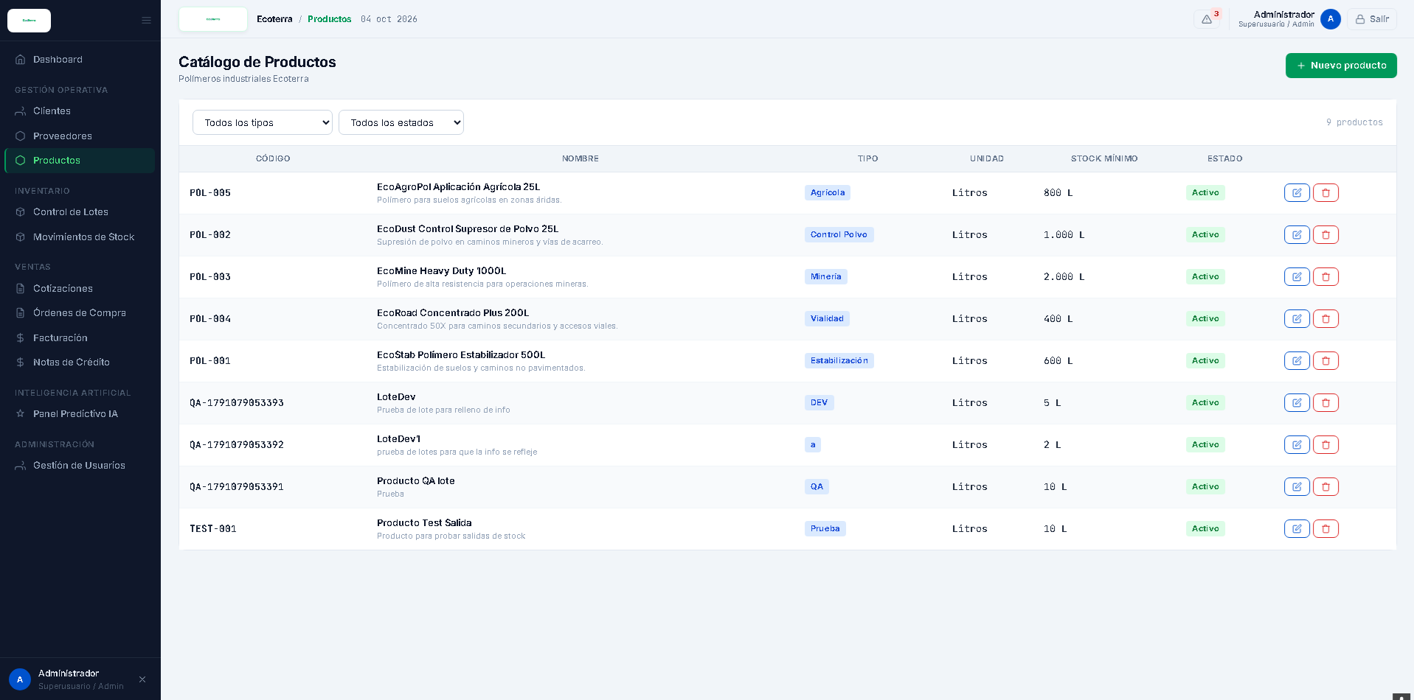

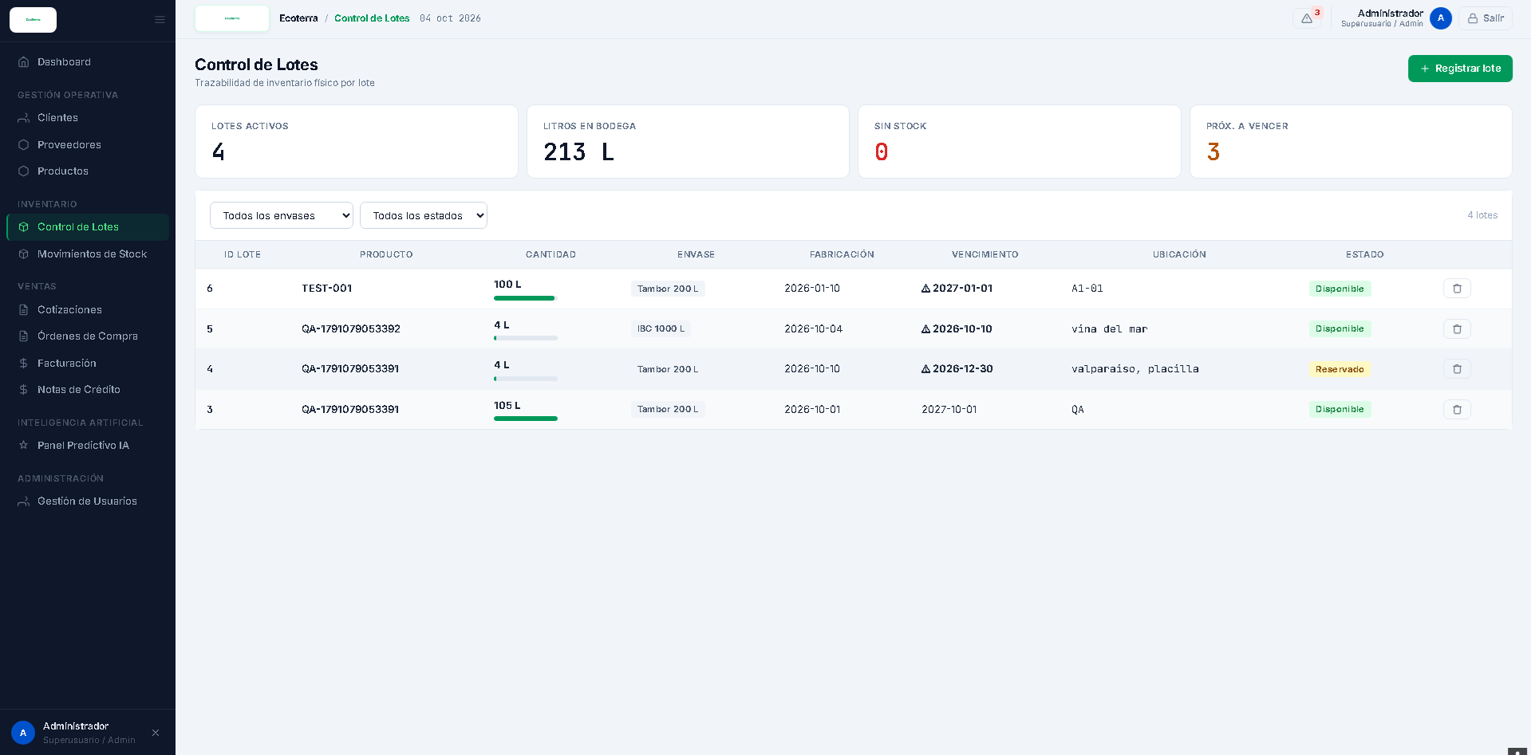

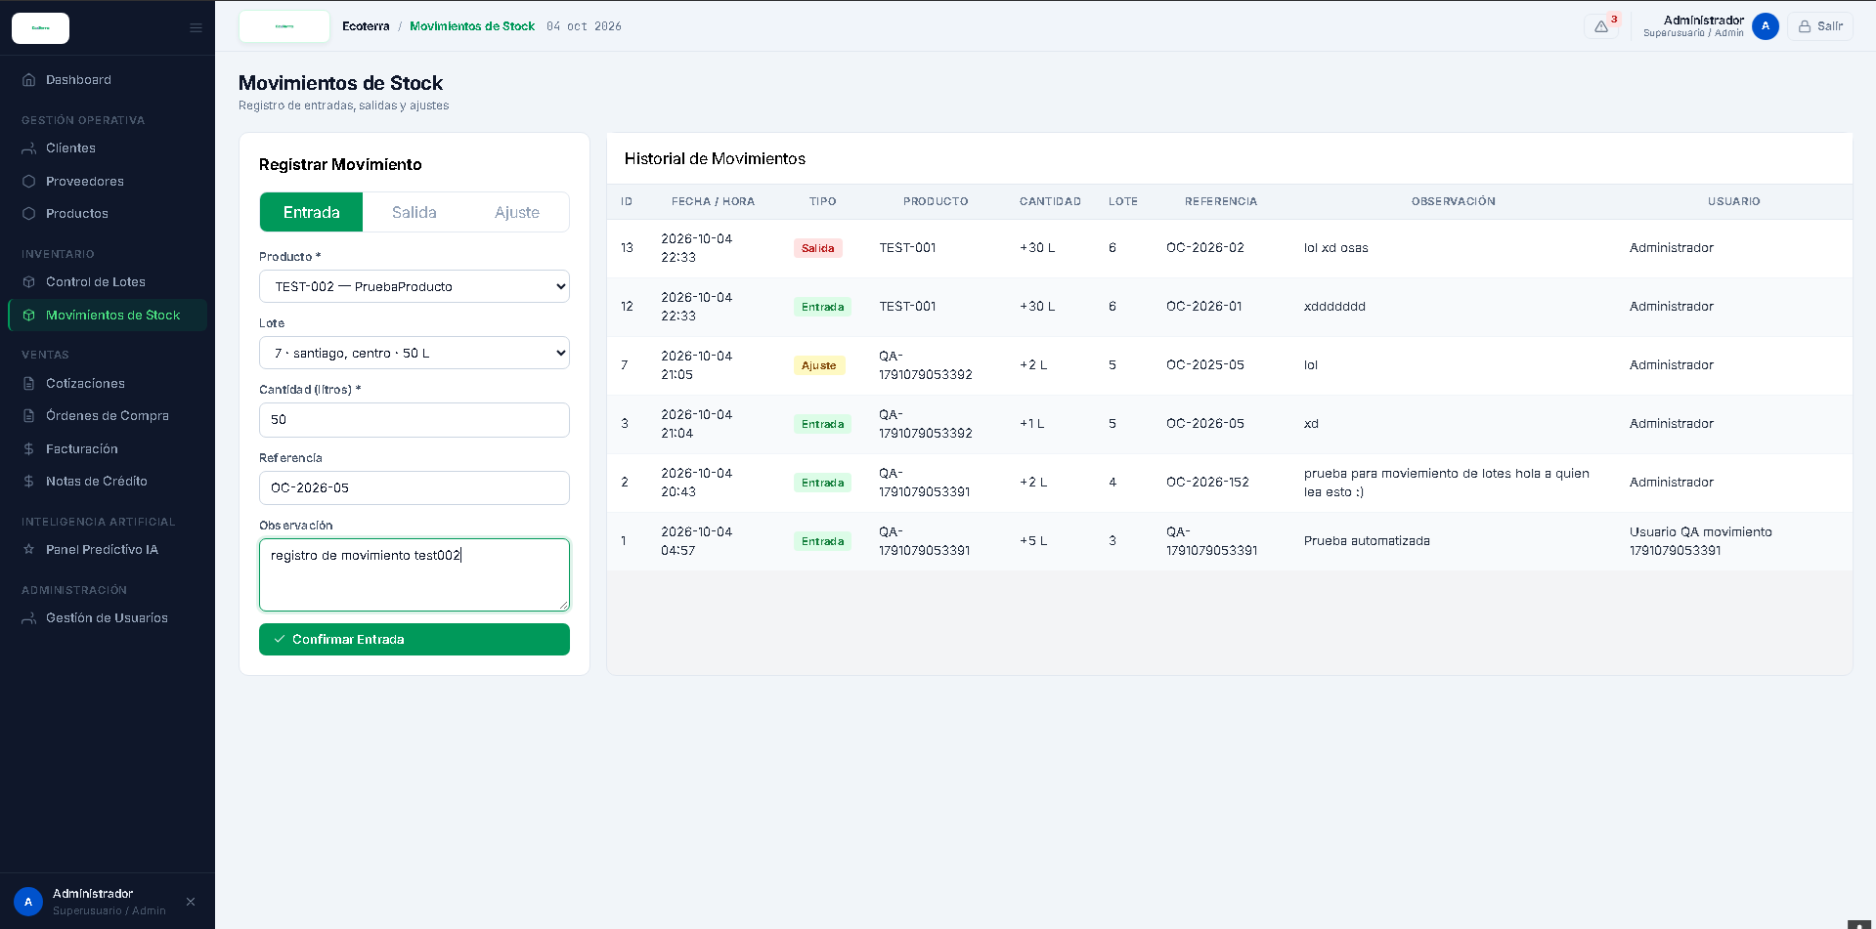

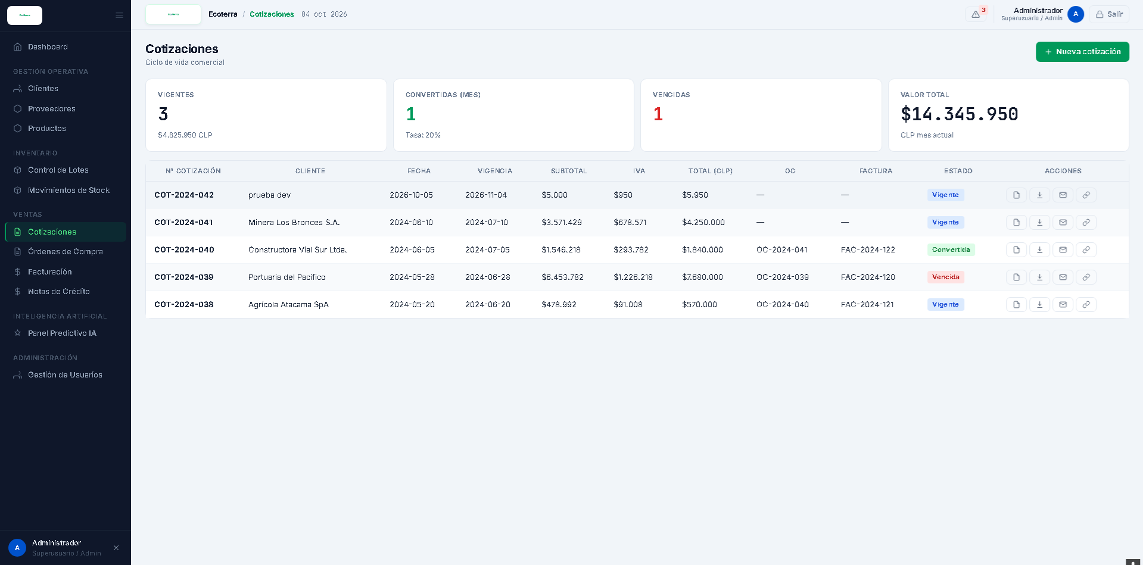

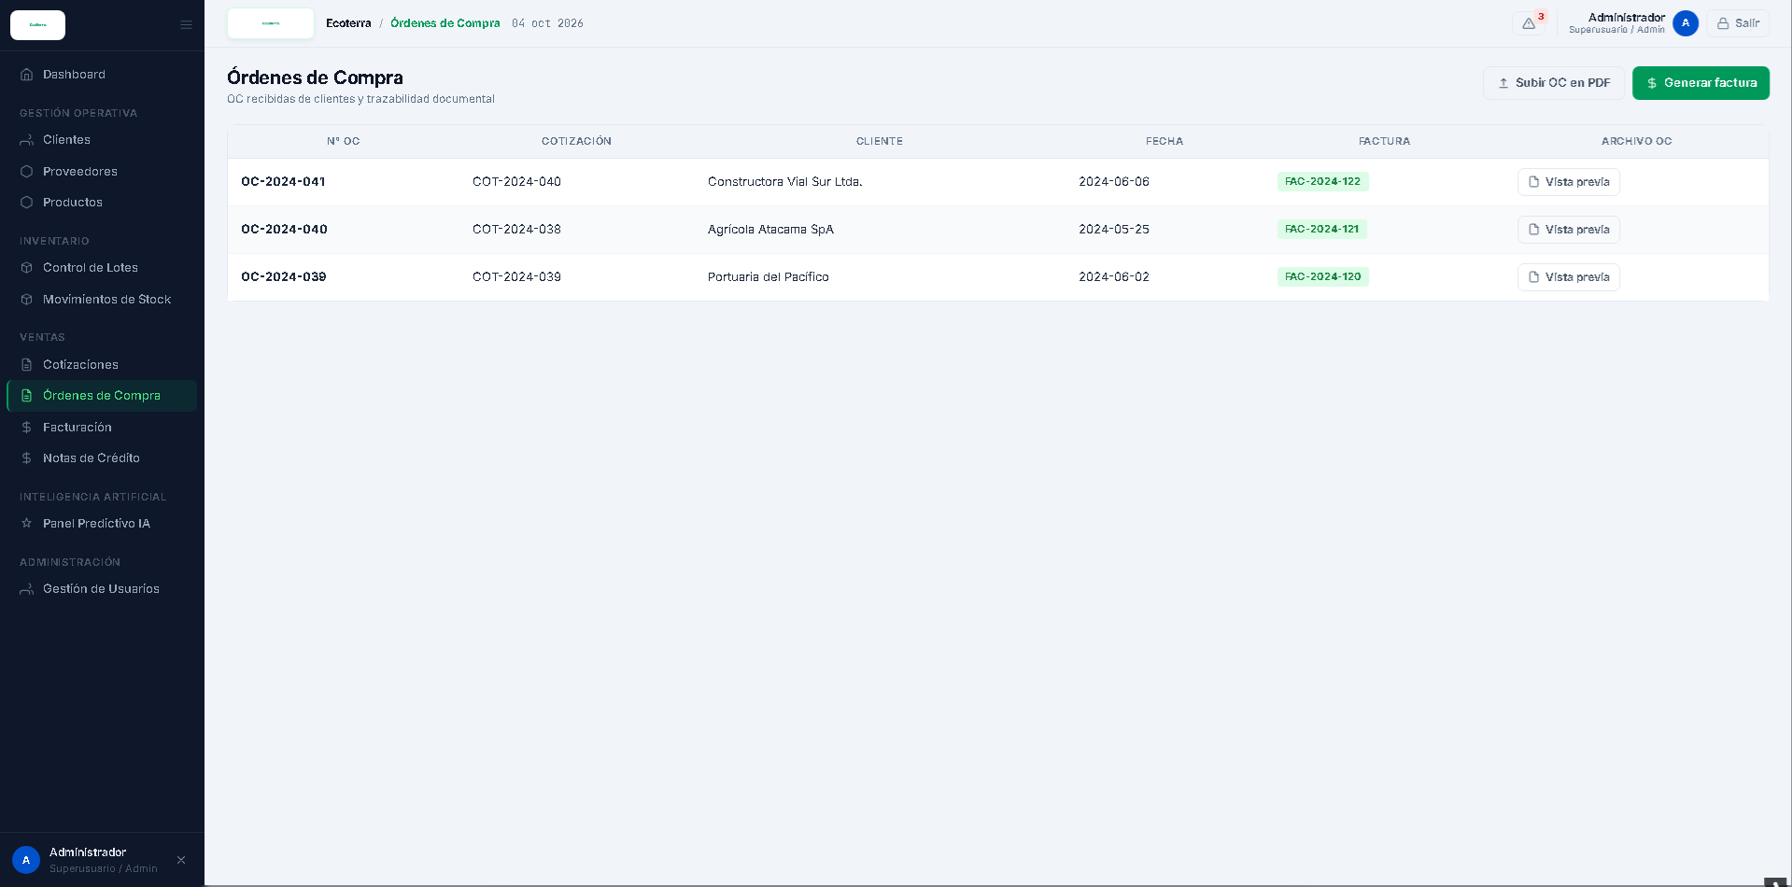

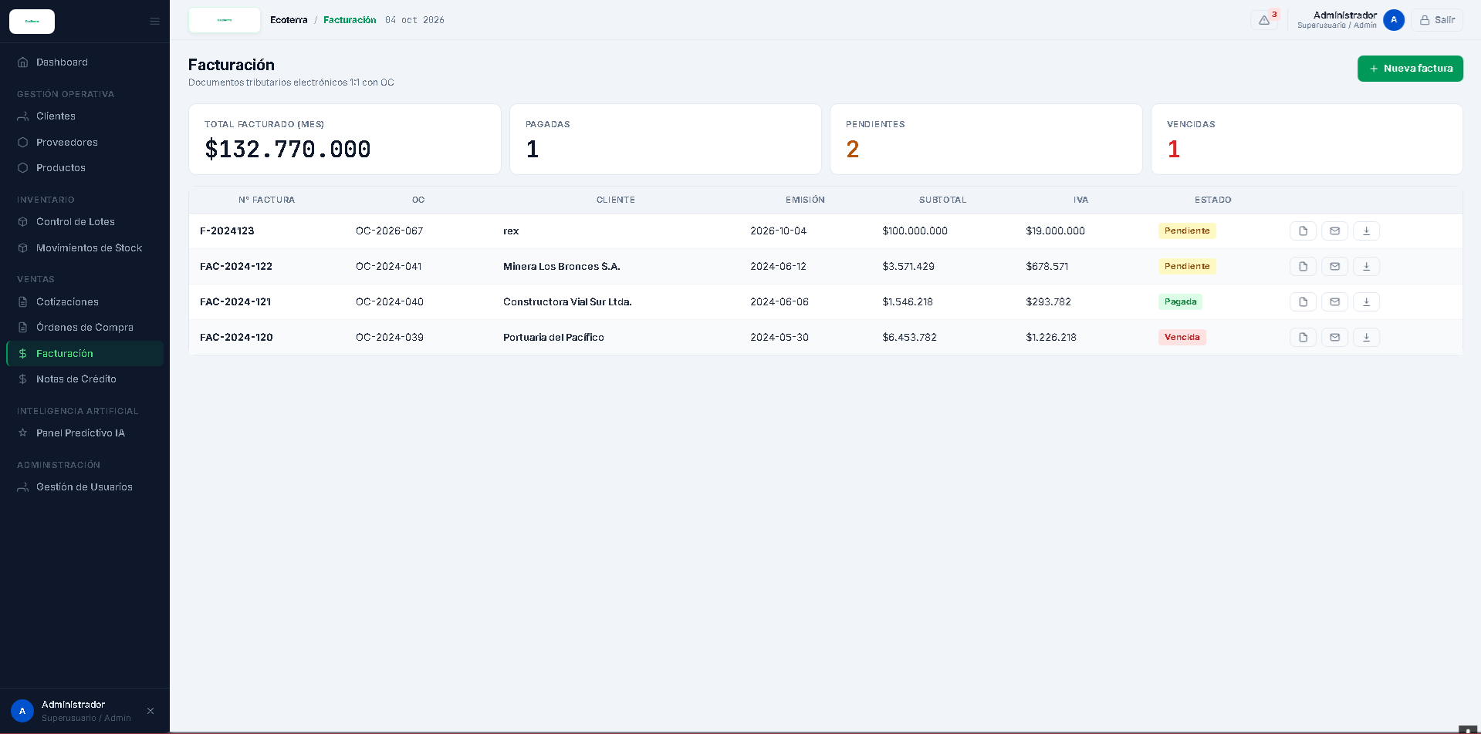

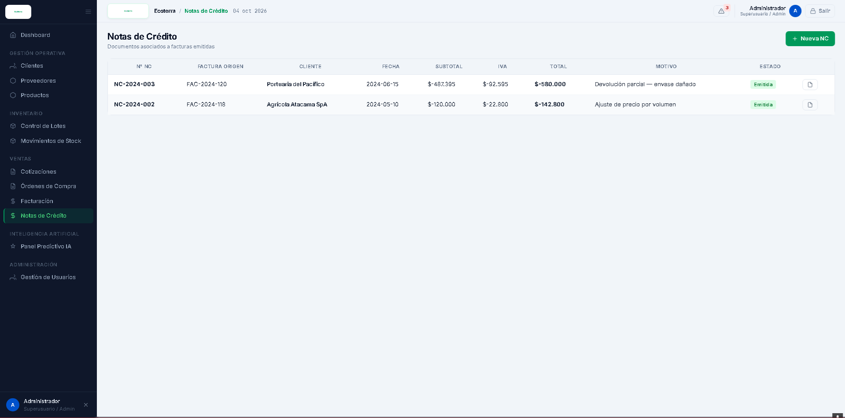

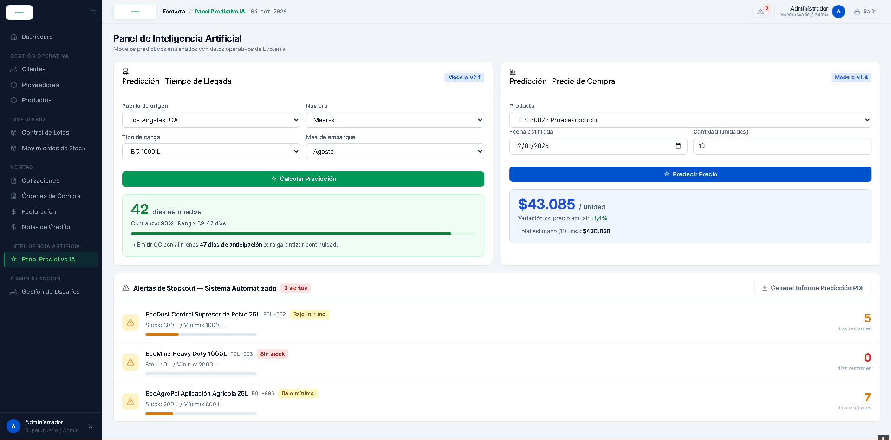

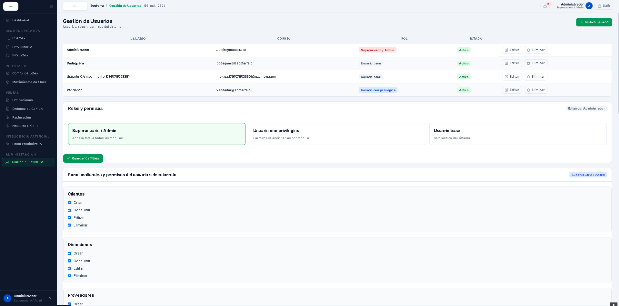

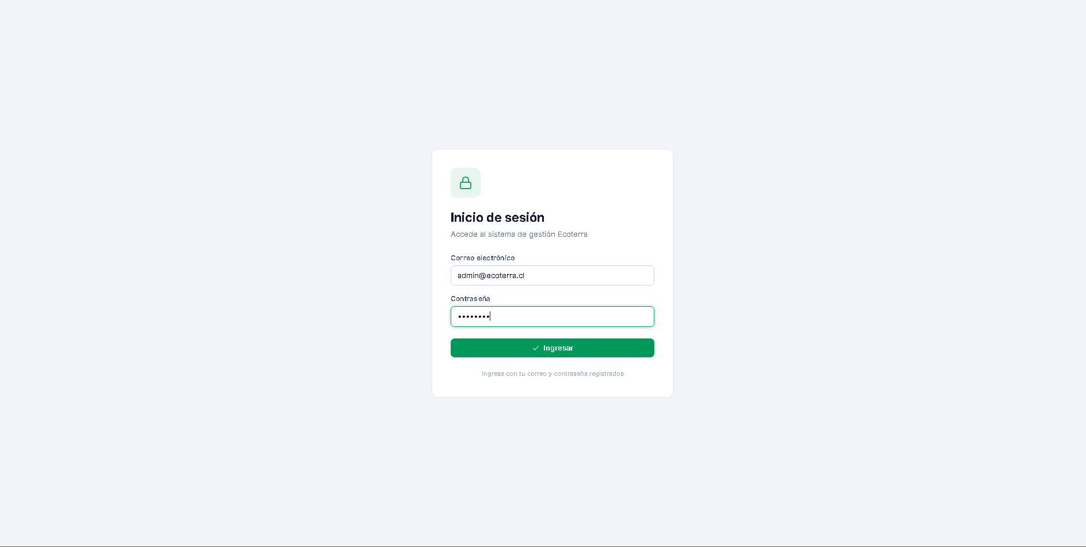

2. Work Plan Monitoring
Carefully examine your work plan, focusing especially on the progress status and adjustments column.
Milestone 1 — Analysis and design
Competency unit | Activities | Resources | Activity duration | Responsible | Observations | Progress status | Adjustments
C2 | Requirements gathering. | Google Meet, Google Docs, Trello, project documentation | W1 - W2 | Araceli Vega | Communication with the client and validation of their needs were required. | Completed | The activity was kept as per the initial plan.
C2 | Requirements validation | Requirements document, meetings with the client | W3 | Araceli Vega | Reviews were carried out to confirm the functional scope. | Completed | The activity was kept, and specific clarifications were made afterwards during development when necessary.
C1 and C4 | Architecture design | UML diagrams, technical documentation, Git/GitHub | W3 - W4 | Ethan Silvestre | The architecture was defined considering the project's modules and technologies. | Completed | The activity was kept; during development, a technical review is planned to ensure correct integration.
C1 and C4 | Database and prototype design | PostgreSQL, Figma, data dictionary, diagrams | W3 - W4 | Kryshsna Cerda / Ethan Silvestre | The initial design served as a basis for development, but some structures required modifications when implementation began. | Adjusted | Elements of the data model and data dictionary were updated during development, incorporating roles, permissions, movements associated with inventory/batch, and other attributes required by the features.
APT Work Plan Monitoring
Based on the monitoring of the initial Work Plan, the four milestones defined for the APT Project were kept, but the distribution of activities within them was adjusted to respond to the team's actual progress and to organize development through Sprints of at most two weeks.
The main change concerns the development stage. Whereas the initial plan distributed activities directly by weeks and modules, the new organization uses Sprints as units of execution and tracking. Accordingly, Milestone 2 is carried out through Sprint 1 and Sprint 2; Milestone 3, through Sprint 3 and Sprint 4; and Milestone 4, through Sprint 5 and the final integration and testing stage.

Milestone 2 — Operations management module
Competency units | Activities | Resources | Activity duration | Responsible | Observations | Progress status | Adjustments
C4 | Frontend completion — Module 1 | React, Tailwind CSS, Figma, Git/GitHub | W5-W6 — Sprint 1 | Ethan Silvestre | The interfaces for the main features of Module 1 were developed. | Completed | Frontend development of these features was concentrated in Sprint 1, instead of developing them simultaneously with the backend.
C3 and C4 | Frontend completion — Module 2 | React, Tailwind CSS, Figma, Git/GitHub | W5-W6 — Sprint 1 | Ethan Silvestre | The interfaces for the main features of Module 2 were developed. | Completed | Frontend development of these features was concentrated in Sprint 1, instead of developing them simultaneously with the backend.
C3 and C4 | Frontend completion — Module 3 | React, Tailwind CSS, Figma, Git/GitHub | W5-W6 — Sprint 1 | Ethan Silvestre | The interfaces for the main features of Module 3 were developed. | Completed | Frontend development of these features was concentrated in Sprint 1, instead of developing them simultaneously with the backend.
C4 | Frontend completion — General review of the three modules | Figma, React, Tailwind CSS, requirements, data dictionary | W6-W7 — Sprint 1 / Sprint 2 transition | Ethan Silvestre / Araceli Vega | The developed interfaces were reviewed and adjustments were identified before integration. | Completed | An explicit frontend review stage was incorporated before starting integration with the backend.
C4 | Backend development of clients and addresses | Django REST Framework, PostgreSQL, Git/GitHub | W7-W8 — Sprint 2 | Benjamín Mateluna | Backend development begins once the corresponding frontend has been reviewed. | In progress | Moved from the general development of Module 1 to a specific backend and integration Sprint.
C4 | Backend development of products, inventory, and batches | Django REST Framework, PostgreSQL, Git/GitHub | W7-W8 — Sprint 2 | Benjamín Mateluna | Inventory rules and the relationship between products and batches must be validated. | In progress | Batch management was explicitly incorporated and the data model was updated to support it.
C3 and C4 | Backend development of inventory movements | Django REST Framework, PostgreSQL, React, Git/GitHub | W7-W8 — Sprint 2 | Benjamín Mateluna / Ethan Silvestre | Movements must be correctly associated with the corresponding inventory/batch. | In progress | The data model was modified by adding id_inventario to MOVIMIENTO and removing id_producto from this table.
C3 and C4 | Backend development of users, roles, permissions, and authentication | Django REST Framework, PostgreSQL, React, Git/GitHub | W7-W8 — Sprint 2 | Benjamín Mateluna / Ethan Silvestre | Coordination between frontend and backend is required to implement the configurable permissions. | In progress | The direct role field in USUARIO was replaced by a structure based on ROL, PERMISO, and ROL_PERMISO, in addition to adding id_rol to USUARIO.
C4 | Backend development of suppliers | Django REST Framework, PostgreSQL, React, Git/GitHub | W7-W8 — Sprint 2 | Benjamín Mateluna | It must be integrated with the previously developed frontend interface. | In progress | It was reorganized within Sprint 2 together with the other Module 1 backend features.
C4 | Integration and testing of Module 1 | Test cases, developed system, Git/GitHub | W8 — Sprint 2 | Benjamín Mateluna / Kryshsna Cerda | It will be run once the priority backend features are implemented. | Not started | Moved to the end of Sprint 2 to validate the complete increment and not only the frontend interfaces.

Milestone 3 — Quotations and invoicing
Competency units | Activities | Resources | Activity duration | Responsible | Observations | Progress status | Adjustments
C4 | Backend development of quotations and quotation details | React, Django REST Framework, PostgreSQL, Git/GitHub | W9-W10 — Sprint 3 | Benjamín Mateluna | Requires using information from clients and products. | Not started | Reorganized as the first part of Sprint 3, prioritizing the start of the commercial flow.
C4 | Backend development of purchase orders | Django REST Framework, PostgreSQL, React, Git/GitHub | W9-W10 — Sprint 3 | Benjamín Mateluna / Ethan Silvestre | The relationship between quotation and purchase order must be validated when applicable. | Not started | The flow was reorganized to implement quotations first and then their association with purchase orders.
C4 | Association of purchase orders and quotations | React, Django REST Framework, PostgreSQL | W9-W10 — Sprint 3 | Benjamín Mateluna / Ethan Silvestre | It must allow the relationship between the two documents to be built correctly. | Not started | Separated as a functional activity within Sprint 3 to make it easier to validate the flow from quotation to purchase order.
C4 | Module 2 integration — commercial stage | Test cases, developed system, Git/GitHub | W10 — Sprint 3 | Benjamín Mateluna / Ethan Silvestre | It will be run once the priority backend features are implemented. | Not started | Reorganized as the last part of Sprint 3, prioritizing the increase of incremental value.
C4 | Development of invoicing and invoice details | Django REST Framework, PostgreSQL, React, Git/GitHub | W11-W12 — Sprint 4 | Benjamín Mateluna / Ethan Silvestre | Depends on the correct operation of the purchase orders. | Not started | Moved to Sprint 4 to maintain a logical sequence: quotation → purchase order → invoice.
C4 | Development of credit notes | Django REST Framework, PostgreSQL, React, Git/GitHub | W11-W12 — Sprint 4 | Benjamín Mateluna | They must be associated with the corresponding invoice. | Not started | Explicitly incorporated into Sprint 4, and the data model was updated with numero_nc.
C4 | Generation and storage of PDF documents | Django, ReportLab, React, PostgreSQL | W11-W12 — Sprint 4 | Ethan Silvestre / Benjamín Mateluna | The documents must be available for consultation. | Not started | Concentrated together with invoicing to achieve a complete integration of the commercial documents.
C4 | Sending quotations and invoices by email | Django, email service, React, Git/GitHub | W11-W12 — Sprint 4 | Ethan Silvestre | Depends on the correct generation of the PDF documents. | Not started | Defined as a specific task within Sprint 4 to facilitate its implementation and validation.
C4 | Complete integration of Module 2 | Test cases, developed system, Git/GitHub | W12 — Sprint 4 | Ethan Silvestre / Benjamín Mateluna | It will be run once the priority backend features are implemented. | Not started | Reorganized as the last part of Sprint 4, prioritizing the increase of incremental value.

Milestone 4 — AI and integration
Competency units | Activities | Resources | Activity duration | Responsible | Observations | Progress status | Adjustments
C1 and C4 | Dataset preparation and cleaning | Python, CSV, PostgreSQL, Git/GitHub | W13 — Sprint 5 | Araceli Vega / Kryshsna Cerda | Part of the historical data may initially be simulated. | Not started | Moved to the beginning of Sprint 5 to prepare the data before training the models.
C1 and C4 | Arrival time prediction model | Python, Scikit-Learn, datasets | W13-W14 — Sprint 5 | Araceli Vega / Kryshsna Cerda | The model's error and behavior must be evaluated. | Not started | Integrated into a common AI Sprint together with the other models to facilitate later integration.
C1 and C4 | Price prediction model | Python, Scikit-Learn, datasets, PostgreSQL | W13-W14 — Sprint 5 | Araceli Vega / Kryshsna Cerda | The variables used and their availability must be validated. | Not started | Reorganized to be developed together with the other predictive models.
C1 and C4 | Stock replenishment prediction model | Python, Scikit-Learn, PostgreSQL, datasets | W13-W14 — Sprint 5 | Araceli Vega / Kryshsna Cerda | Uses information related to inventory and sales. | Not started | Incorporated into the same AI development cycle to facilitate the joint preparation and integration of the data.
C1 and C4 | Integration of the models with the backend | Python, Scikit-Learn, Django REST Framework, APIs, Git/GitHub | W14 — Sprint 5 | Benjamín Mateluna / Kryshsna Cerda | May require adjustments between the models, backend, and frontend. | Not started | Integration was moved to a stage after the development of the models, within the same Sprint 5.
C1 and C4 | AI panel integration | Python, Scikit-Learn, Django REST Framework, APIs, Git/GitHub | W14 — Sprint 5 | Benjamín Mateluna / Kryshsna Cerda | Requires the 3 developed models to work correctly. | Not started | Integration was moved to a stage after the development of the models, within the same Sprint 5.
C4 | General integration and final testing | Test cases, complete system, Git/GitHub | W15 | Whole team | The three modules and the predictive models must be considered. | Not started | A specific week was set for integration and final testing, separate from feature development.
C3 | Validation, final report, documentation, and presentation preparation | Word/Google Docs, PowerPoint, evidence, Trello | W16-W18 | Whole team | Documentation and presentation tasks will be distributed among the team members. | Not started | The original plan is maintained, incorporating the evidence generated during the new Sprints and documenting the adjustments made.

Actividad Scrum
Competency units | Activities | Resources | Activity duration | Responsible | Observations | Progress status | Adjustments
C3 | Definition and management of the Product Backlog | Trello, requirements | W1-W18 | Araceli Vega | The backlog may be modified in response to validations and justified changes. | In progress | Maintained as a cross-cutting activity, incorporating the new technical tasks resulting from the reorganization.
C3 | Sprint Planning | Trello, Product Backlog, Sprint Backlog | Start of each Sprint | Kryshsna Cerda / Whole team | Allows setting the goal and work of each Sprint. | In progress | Changed from planning centered mainly on weeks/milestones to Sprint-specific planning.
C3 | Daily Scrum and tracking | Trello, progress log, Meet | W5-W15 | Whole team | Allows identifying progress, pending tasks, and impediments. | In progress | Maintained as a cross-cutting activity, and Trello is used to visualize the status of the tasks.
C3 | Sprint Review | System, prototypes, evidence, Meet | End of each Sprint | Whole team / Araceli Vega | Allows reviewing the increment and determining adjustments. | In progress | Reorganized according to the close of each Sprint, instead of using only the milestones as review points.
C3 | Sprint Retrospective | Sprint log, Trello, minutes | End of each Sprint | Whole team / Kryshsna Cerda | Allows identifying improvements for the next cycle. | In progress | Maintained as a continuous improvement instance, and its agreements are taken into account in the following Sprint.
C3 | Record of progress, impediments, and agreements | Trello, records, documents, Git/GitHub | W1-W18 | Kryshsna Cerda / Whole team | Serves as a record of the process and of the decisions made. | In progress | The record-keeping was reinforced due to the changes made to the planning and organization of development.

3. Adjustments Based on Monitoring
Go deeper into the observations of your work plan. Analyze the planned activities and point out which aspects facilitated or hindered the execution of the plan. Explain how you addressed and/or will address the obstacles. Finally, indicate the adjustments you made to the work plan based on this analysis.

Factors that have facilitated and/or hindered the development of my work plan:
Among the main facilitators are the organization through Scrum, the use of Trello to track tasks, and the availability of tools such as Figma, React, Git/GitHub, and Django. In addition, coordination among the team members made it possible to distribute responsibilities according to their areas of work.
As a difficulty, during development it was necessary to adapt some interfaces and data structures, especially in the management of users, roles, permissions, and inventory. To address this, frontend reviews, data model updates, and a reorganization of tasks by Sprint were carried out before continuing with integration.

Adjusted or eliminated activities:
No relevant activities were eliminated from the project scope. The main adjustments concerned the sequence and distribution of the activities. The development of the frontend of the three modules was brought forward and concentrated in Sprint 1, leaving the backend and integration for the following Sprints.
Activities related to users, roles and permissions, inventory movements, and data structure were also updated, due to the needs identified during development. These changes make it possible to maintain the defined objectives and features, adapting their implementation to the project's actual progress.

Activities that have not started or are delayed:
The Module 1 backend activities are in progress, while those corresponding to quotations, invoicing, and predictive models have not yet started, due to the new Sprint sequence defined for the project.
To avoid affecting development, progressive implementation will continue by Sprint, carrying out integration and testing at the close of each cycle. In this way, the aim is to detect possible difficulties early and keep progress toward the established milestones and objectives.

